**COMPILER DESIGN – CSA1465**

**Program 1:**

%{

#include<stdio.h>

%}

%%

[A-Z]+[\t\n ] { printf("%s",yytext); }

. ;

%%

int main( )

{

printf("Enter some string with capital words in between\n");

yylex();

}

int yywrap( )

{

return 1;

}

**OUTPUT:**

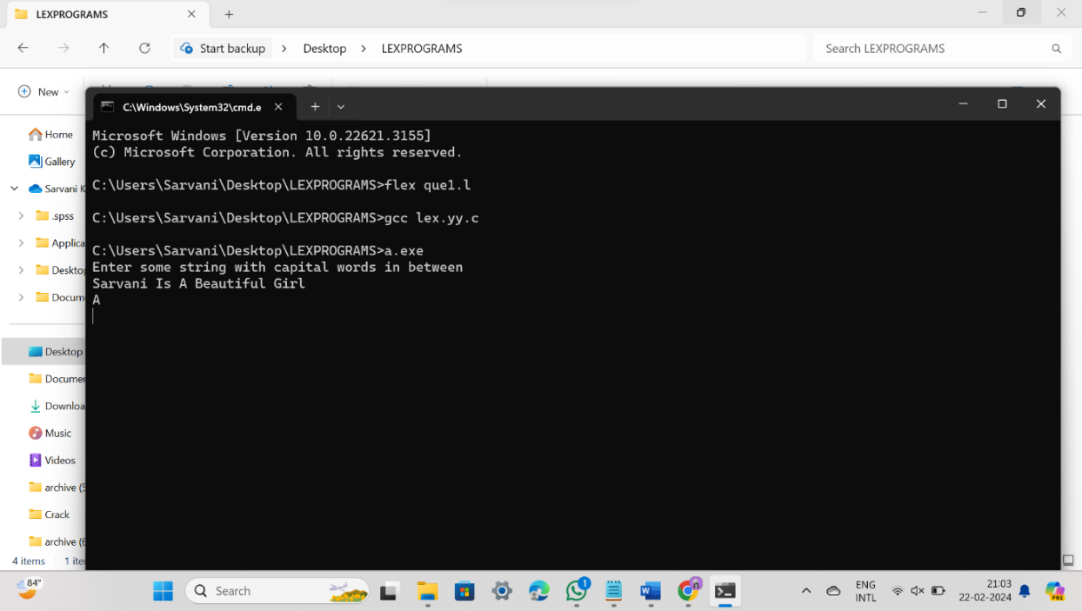

**PROGRAM 2**

%{

#include<stdio.h>

%}

%%

[0-9]+|[0-9]*\.[0-9]+ { printf("\n%s is DIGIT", yytext);}

.+ { printf("\n%s is NOT A DIGIT",yytext);}

%%

int yywrap(){}

int main()

{

yylex();

}

**OUTPUT:**

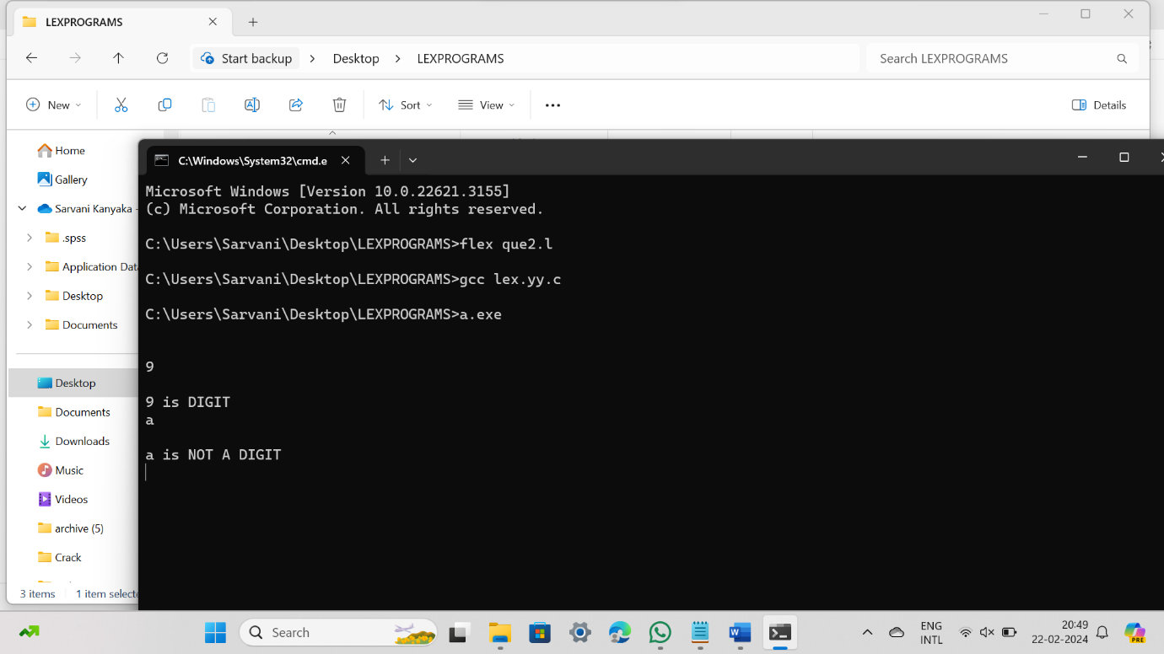

**PROGRAM 3:**

%%

[1-9][0-9]{9} {printf("\nMobile Number Valid\n");}

.+ {printf("\nMobile Number Invalid\n");}

%%

int main()

{

printf("\nEnter Mobile Number : ");

yylex();

printf("\n");

return 0;

}

int yywrap()

{ }

**OUTPUT:**

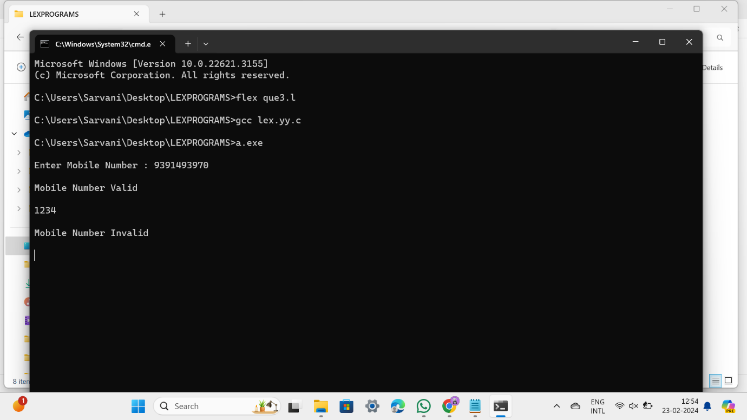

**PROGRAM 4**

%{

int vcount=0;

int ccount=0;

%}

%%

[aeiouAEIOU] {vcount++;}

[a-z,A-Z] {ccount++;}

%%

int yywrap(){}

int main()

{

printf("enter the string with vowels and consonants:");

yylex();

printf("\n no of vowels ::%d \n",vcount);

printf("\n no of consonants ::%d \n",ccount);

}

**OUTPUT:**

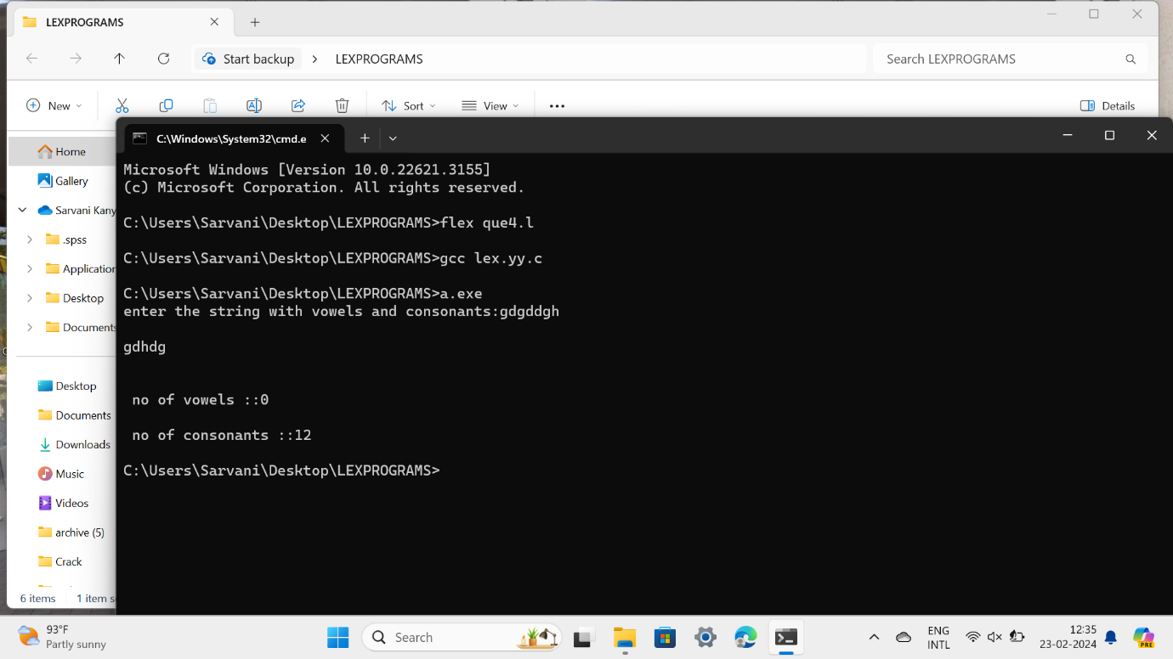

**PROGRAM 5**

%{

#include <stdio.h>

%}

%option noyywrap

%%

int|float|char { printf("Keyword: %s\n", yytext); }

[a-zA-Z][a-zA-Z0-9]* { printf("Identifier: %s\n", yytext); }

.|\n ; /* Ignore other characters */

%%

int main() {

yylex();

return 0;

}

**OUTPUT:**

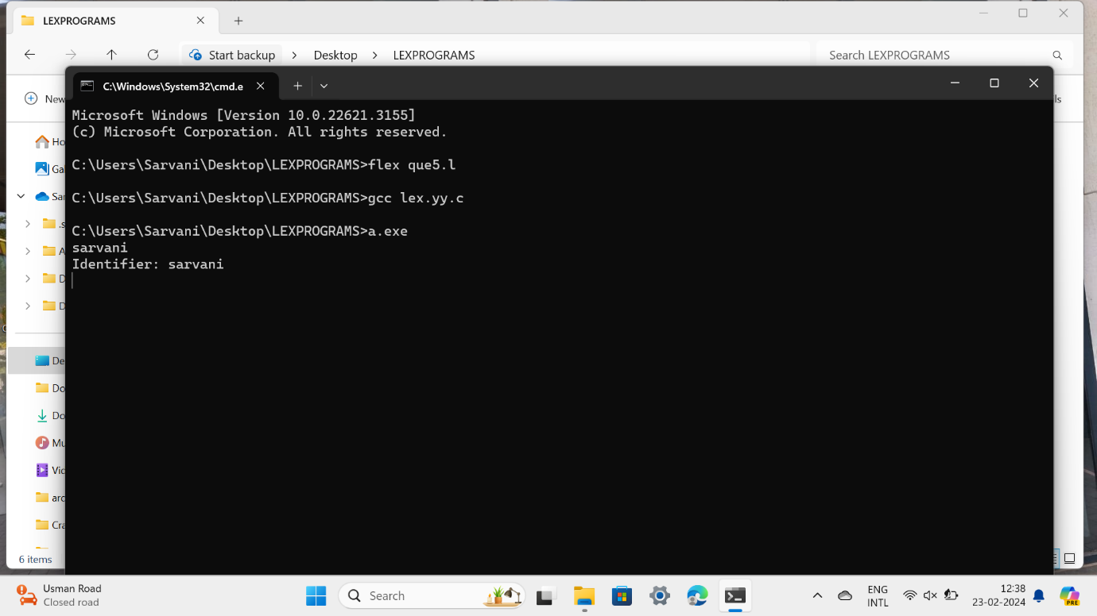

**PROGRAM 6**

%{

int positive_no = 0, negative_no = 0;

%}

%%

^[-][0-9]+ {negative_no++;

printf("negative number = %s\n",

yytext);} // negative number

[0-9]+ {positive_no++;

printf("positive number = %s\n",

yytext);} // positive number

%%

int yywrap(){}

int main()

{

yylex();

printf ("number of positive numbers = %d,"

"number of negative numbers = %d\n",

positive_no, negative_no);

return 0;

}

**OUTPUT:**

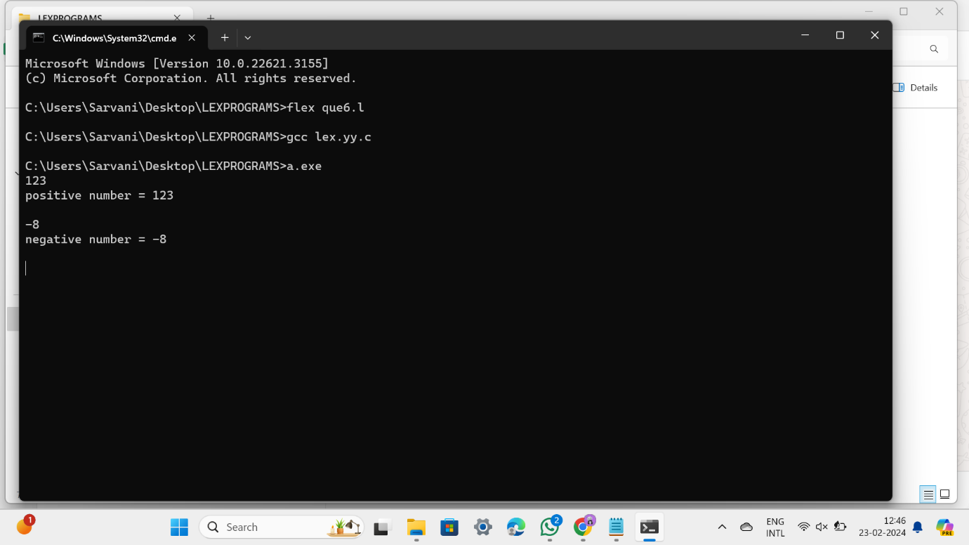

**PROGRAM 7**

[0-9]+ { printf("Number: %s\n", yytext); }

[a-zA-Z]+ { printf("Word: %s\n", yytext); }

.|\n;

%%

int main() {

yylex();

return 0;

}

PROGRAM 8

%%

[aeiouAEIOU][a-zA-Z]* { printf("String starting with vowel: %s\n", yytext); }

.|\n;

%%

int main() {

yylex();

return 0;

}